Year 10 Semester One - Paper A

Mathematics Examination
Part Two: Calculators Allowed

Name ________________________________ Teacher _______________________

TIME ALLOWED FOR THIS PAPER
Reading time before commencing : 5 minutes.
Working time for paper : 50 minutes.

MATERIAL REQUIRED /RECOMMENDED FOR THIS PAPER

TO BE PROVIDED BY THE SUPERVISOR
This question paper comprising 5 questions.
Attempt ALL questions.
Total marks for the paper : 75
Answers are to be written on this test booklet in the spaces provided.

TO BE PROVIDED BY THE CANDIDATE
Pens, pencils, eraser, ruler, Scientific Calculator
One (1) A4 page of notes (handwritten, photocopied or typed on both sides) that may be either personally or commercially produced.

INSTRUCTIONS TO CANDIDATES
Write all answers in the spaces provided - if working is completed on extra pages, indicate on the original question that your working continues elsewhere.
If extra paper is needed in any section, please ask one of the supervisors.

Show all working clearly, in sufficient detail to allow your answers to be checked readily and for marks to be awarded for reasoning. No marks will be awarded to incorrect answers without supporting reasoning.

Question | Total possible marks | Your mark
1 | 17
2 | 13
3 | 15
4 | 20
5 | 10
Total | 75
Question 1 [17 marks]

a) Write down the equation of a line which is parallel to the y-axis and passes through the point (–3, 2).

[1]

b) Find the equation of the line that passes through (1, 5) and has a gradient of .

[3]

c) Find the equation of the line passing through the point (–2, 4) and (3, –2).

[4]

d) Find the equation of a line that is perpendicular to y =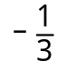 x + 1 and contains the point (–3, 4).

[4]

e) Solve the following pair of simultaneous equations algebraically. Show all of your working.

3x + 4y = –5
x – y = 3

[5]

Question 2 [13 marks]
a) Complete the square for each of the following:
(i) x² + 2x – 10 (ii) –x² – 2x + 10

[5]
b) Hence, or otherwise, make a sketch of the curves,
y = x² + 2x – 10 and y = –x² – 2x + 10 ,
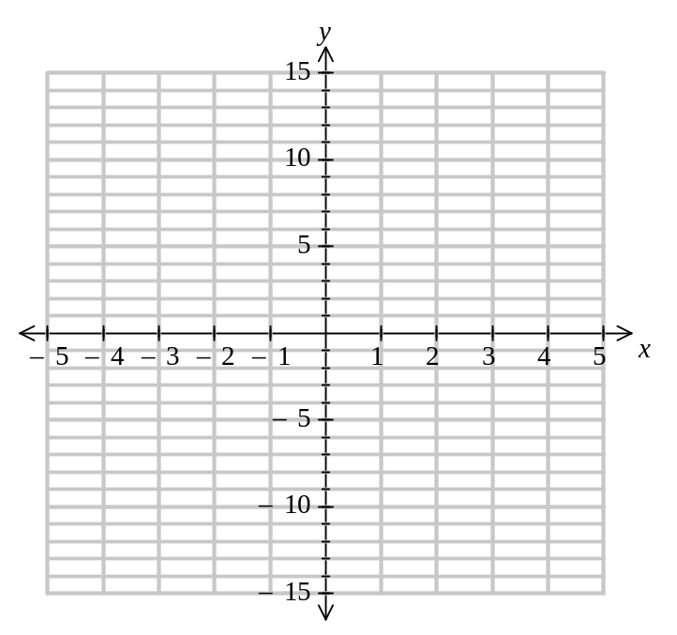 on the following axis. Indicate clearly the turning points, y intercepts and lines of symmetry.

[6]
c) (i) Use your graph to estimate a solution(s) for the equation:
0 = x² + 2x – 10

(ii) How can you verify that your solution(s) is correct?

[2]

Question 3 [15 marks]

a) (i) Next to each function below, state whether the relationship between x and y is linear (L), quadratic (Q), exponential (E) or reciprocal (R). All other variable represent constants.

y = a(x – b)² + c ___________ y = ax +b ___________
y = ab^{x} ___________ xy = b ___________ y = ax²+bx +c ___________ y = a(x + b)(x + c) ___________
[6]
(ii) State whether the relationship between x and y is linear (L), quadratic (Q), exponential (E) or reciprocal (R) by placing the appropriate letter next to the graph.
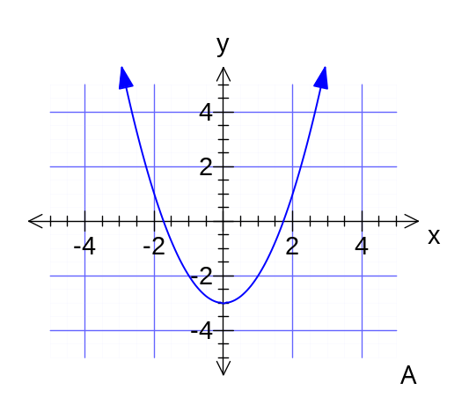  A | 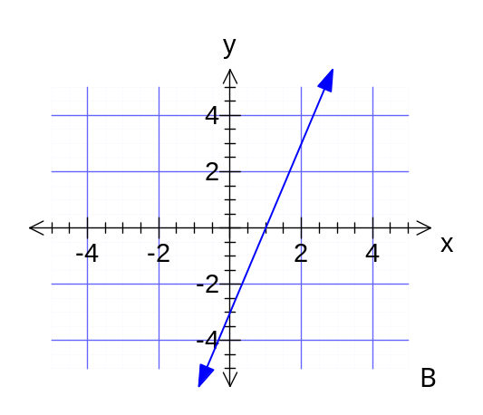  B
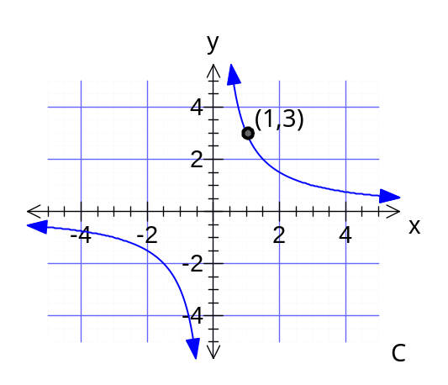  C | 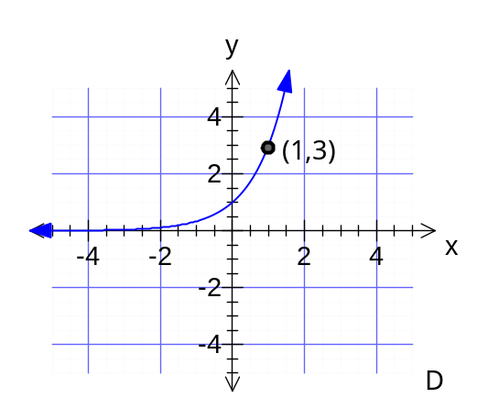  D

[4]
(iii) Determine the equation for each graph:

A _______________________ B _______________________

C _______________________ D _______________________
[5]
Question 4 [20 marks]
a) (i) Pick out the six pairs of similar triangles and give the reason for similarity in each case.

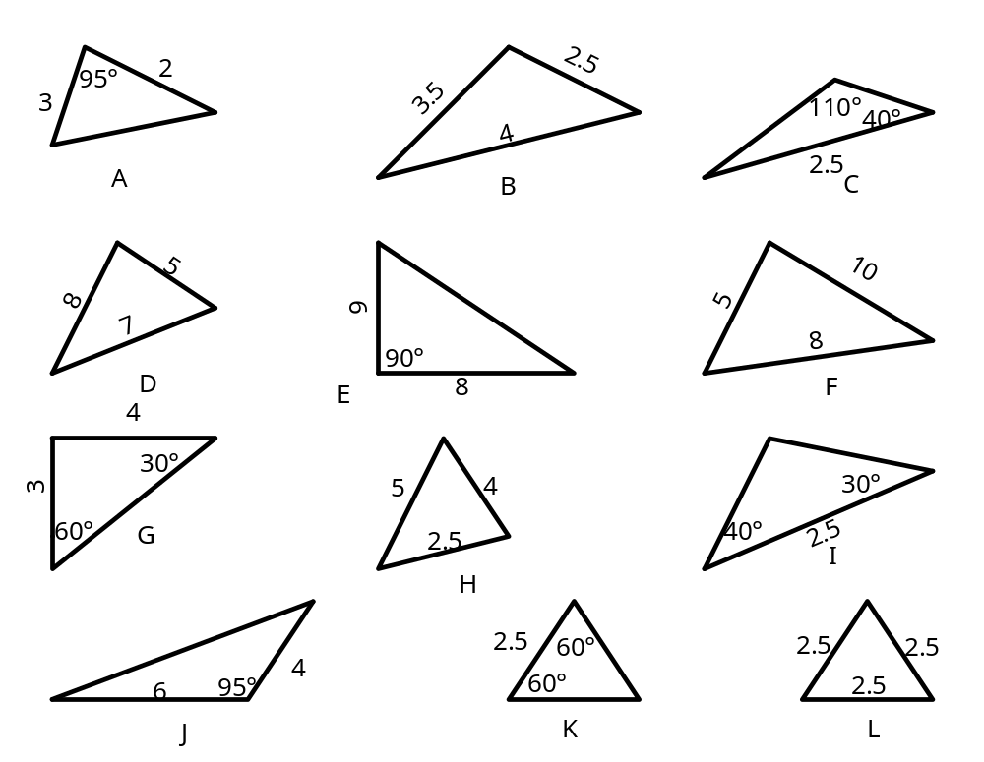
6

[6]

(ii) Which of the pairs of similar triangles are also congruent?
What condition for congruent triangles did you use to make this judgement?

[4]
b) In the following diagram, Δ LQP ~ Δ LMN. Determine the lengths LM and MN.
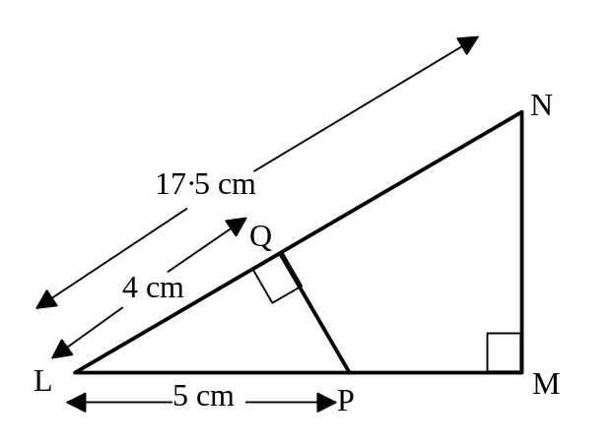

[5]

c) A mobile tower 24 metres high has two parallel wires that join from the mast to the ground. The first wire is 26m long and is fastened to a point on the ground 10 metres from the bottom of the mast and also to the top of the mast. The second wire is fastened below the first wire and this is connected to a point on the ground 7.5 m from the foot of the mast. Determine the length of the second wire and how far up the mast it is fastened.

[5]
Question 5 [10 marks]

a) The longer of two supporting wires for a radio mast is inclined at 22º to the horizontal and is 4 m from the shorter wire. The shorter wire is 11m long.

(i) Find the angle between the two wires.
4 m
22º
11 m

(ii) Determine the length of the longer wire.

(iii) Find the height of the tower.

[6]

b) Two skiers leave the ski lift at noon and set off down the mountain. One heads for a tree (silly idea) 15m off to the right, whilst the other heads to the left at 2m/s. It takes the first skier 12 seconds to reach the tree. Her friend is now 18m away from her.

(i) Draw a diagram to represent the situation above.

(ii) At what angle did they first separate?

[4]

